Intersecting Chords Theorem
# Source: AI Source: Provided by: [Data Path: Persons Table -> ID Column: 1, Name_En Column: Motasem Essam] -> From: [ChatGPT] on [7/25/2026]
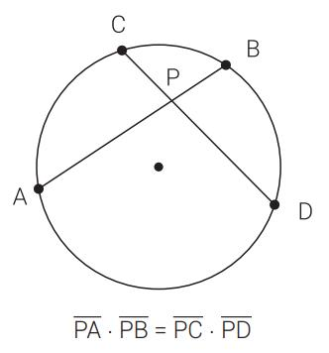
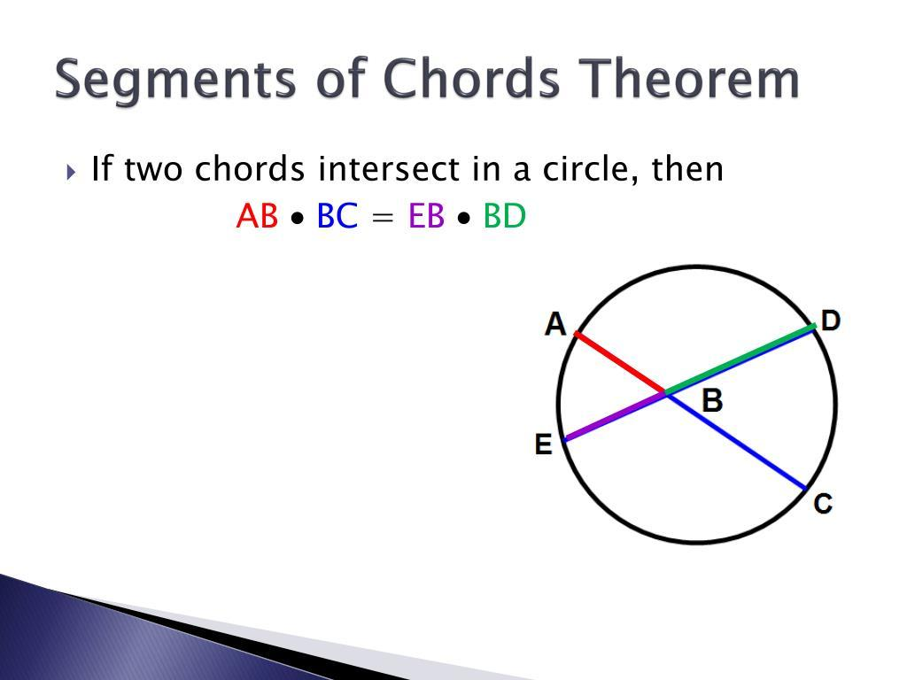
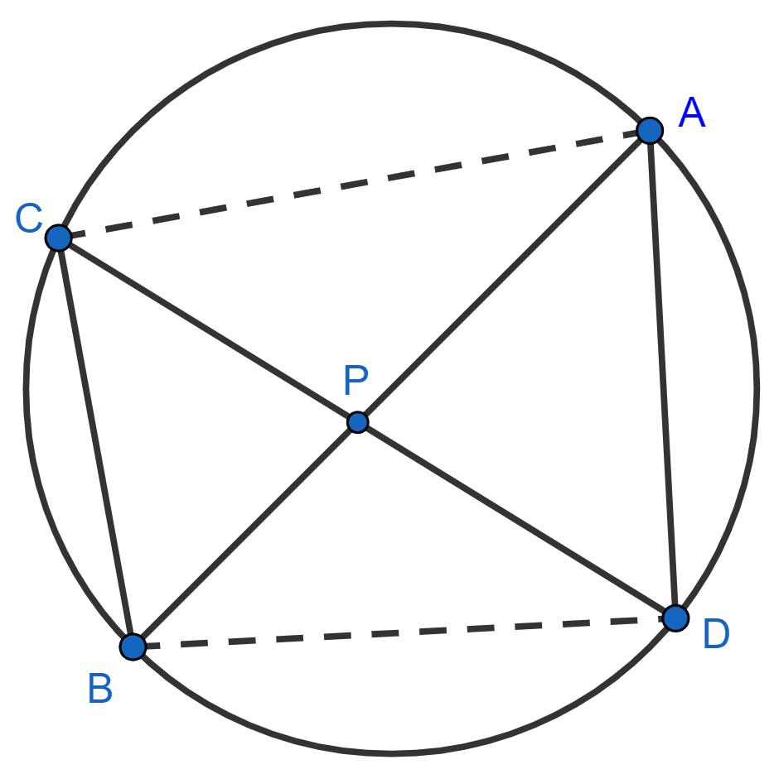
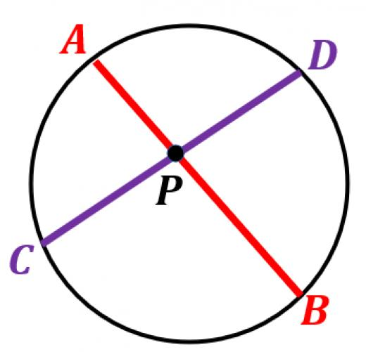

Definition
# Source: AI Source: Provided by: [Data Path: Persons Table -> ID Column: 1, Name_En Column: Motasem Essam] -> From: [ChatGPT] on [7/25/2026]
The Intersecting Chords Theorem states that when two chords of a circle intersect at a point inside the circle, the products of the lengths of the two segments of one chord and the two segments of the other chord are equal.
If chords $AB$and $CD$intersect at $P$, then:
$$\boxed{PA⋅PB=PC⋅PD}$$
In words:
The product of the two segments of one chord equals the product of the two segments of the other chord.

Fundamental Concept
# Source: AI Source: Provided by: [Data Path: Persons Table -> ID Column: 1, Name_En Column: Motasem Essam] -> From: [ChatGPT] on [7/25/2026]
Suppose two chords intersect inside a circle:
$$A-P-B$$
and:
$$C-P-D$$
Then:
$$\boxed{PA⋅PB=PC⋅PD}$$
Here, $P$is the internal intersection point.
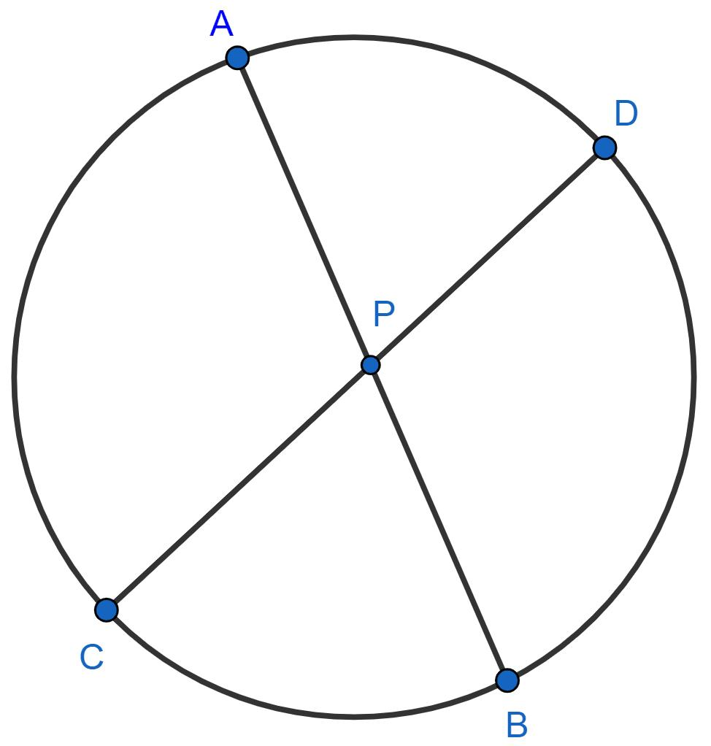
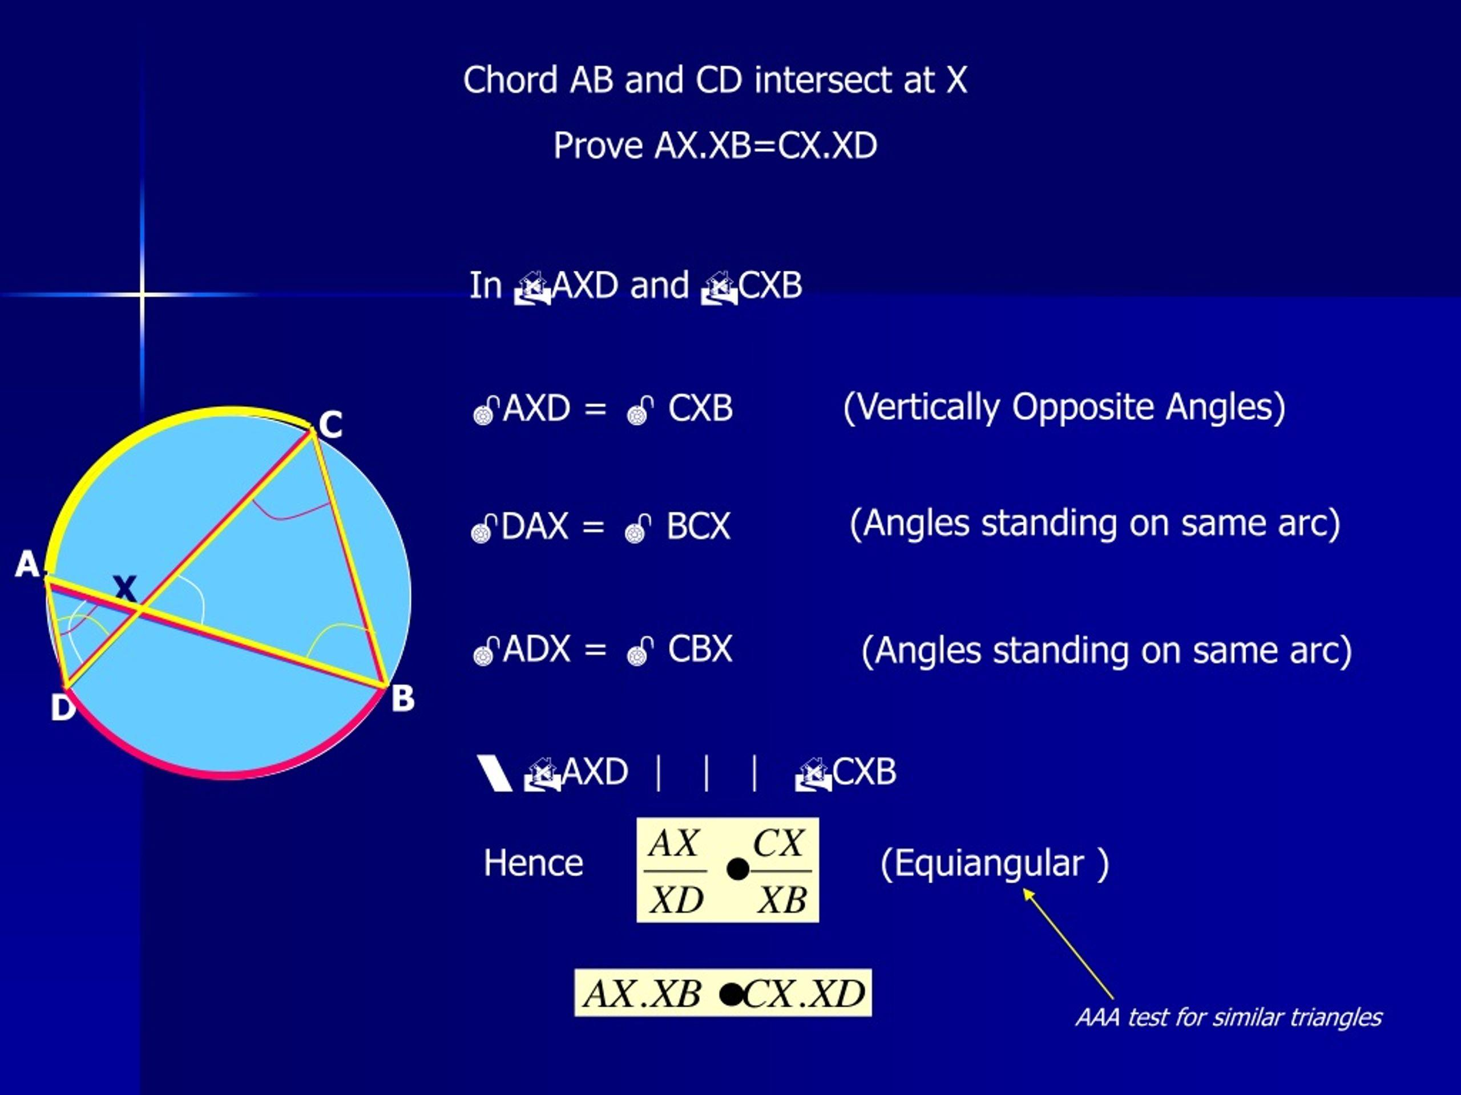

Main Parts
# Source: AI Source: Provided by: [Data Path: Persons Table -> ID Column: 1, Name_En Column: Motasem Essam] -> From: [ChatGPT] on [7/25/2026]
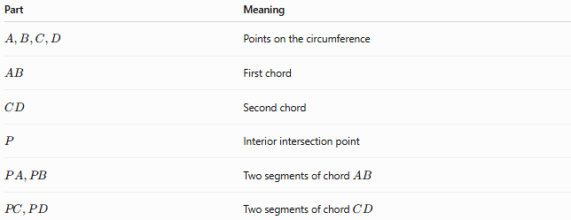
Part | Meaning
$$A,B,C,D$$ | Points on the circumference
$$AB$$ | First chord
$$CD$$ | Second chord
$$P$$ | Interior intersection point
$$PA,PB$$ | Two segments of chord $AB$
$$PC,PD$$ | Two segments of chord $CD$
The fundamental relationship is:
$$\boxed{PA⋅PB=PC⋅PD}$$

Theorem Statement
# Source: AI Source: Provided by: [Data Path: Persons Table -> ID Column: 1, Name_En Column: Motasem Essam] -> From: [ChatGPT] on [7/25/2026]
If two chords intersect inside a circle, the product of the lengths of the segments of one chord equals the product of the lengths of the segments of the other chord.
Therefore:
$$\boxed{PA⋅PB=PC⋅PD}$$
This is also called the Intersecting Chords Theorem or Chord–Chord Theorem.

Example 1 — Direct Application
# Source: AI Source: Provided by: [Data Path: Persons Table -> ID Column: 1, Name_En Column: Motasem Essam] -> From: [ChatGPT] on [7/25/2026]
Suppose:
$$PA=4, PB=12$$
and:
$$PC=6$$
Find $PD$.
Using:
$$PA⋅PB=PC⋅PD$$
we get:
$$4\left(12\right)=6\left(PD\right) \\ 48=6PD$$
Therefore:
$$\boxed{PD=8}$$

Example 2 — Finding an Unknown Segment
# Source: AI Source: Provided by: [Data Path: Persons Table -> ID Column: 1, Name_En Column: Motasem Essam] -> From: [ChatGPT] on [7/25/2026]
Suppose:
$$PA=5, PB=15, PC=3$$
Then:
$$5\left(15\right)=3\left(PD\right) \\ 75=3PD$$
Therefore:
$$\boxed{PD=25}$$

Example 3 — Algebraic Problem
# Source: AI Source: Provided by: [Data Path: Persons Table -> ID Column: 1, Name_En Column: Motasem Essam] -> From: [ChatGPT] on [7/25/2026]
Suppose:
$$PA=x, PB=12, PC=4, PD=6$$
Then:
$$x\left(12\right)=4\left(6\right) \\ 12x=24 \\ \boxed{x=2}$$

Proof of the Theorem
# Source: AI Source: Provided by: [Data Path: Persons Table -> ID Column: 1, Name_En Column: Motasem Essam] -> From: [ChatGPT] on [7/25/2026]
Consider two chords $AB$and $CD$intersecting at $P$.
Connect $A$to $C$.
Consider:
$$△APC$$
and:
$$△DPB$$
Because the chords intersect:
$$∠APC=∠DPB$$
These are vertical angles.
Also, because $A,B,C,D$lie on the same circle:
$$∠ACP=∠DBP$$
These are inscribed angles subtending the same arc.
Therefore:
$$△APC∼△DPB$$
From similarity:
$$\frac{PA}{PD}=\frac{PC}{PB}$$
Cross-multiplying:
$$PA⋅PB=PC⋅PD$$
Therefore:
$$\boxed{PA⋅PB=PC⋅PD}$$

Geometric Interpretation
# Source: AI Source: Provided by: [Data Path: Persons Table -> ID Column: 1, Name_En Column: Motasem Essam] -> From: [ChatGPT] on [7/25/2026]
The theorem says that the position of the intersection point $P$determines a fixed product along every chord passing through $P$.
For chord $AB$:
$$PA⋅PB$$
For chord $CD$:
$$PC⋅PD$$
These products are equal:
$$\boxed{PA⋅PB=PC⋅PD}$$
This common value is related to the Power of a Point.

Relationship with Power of a Point
# Source: AI Source: Provided by: [Data Path: Persons Table -> ID Column: 1, Name_En Column: Motasem Essam] -> From: [ChatGPT] on [7/25/2026]
For an internal point $P$, the intersecting-chords relationship is:
$$\boxed{PA⋅PB=PC⋅PD}$$
Under the signed power convention, because $P$is inside the circle:
$$\boxed{Pow⁡\left(P\right)=-PA⋅PB}$$
and also:
$$\boxed{Pow⁡\left(P\right)=-PC⋅PD}$$
However, in elementary geometry, the theorem is usually stated simply as:
$$\boxed{PA⋅PB=PC⋅PD}$$
without introducing negative power.

Comparison with the Secant–Secant Theorem
# Source: AI Source: Provided by: [Data Path: Persons Table -> ID Column: 1, Name_En Column: Motasem Essam] -> From: [ChatGPT] on [7/25/2026]
The formulas are identical:
Intersecting Chords
The intersection point is inside the circle:
$$\boxed{PA⋅PB=PC⋅PD}$$
Secant–Secant
The common point is outside the circle:
$$\boxed{PA⋅PB=PC⋅PD}$$
The difference is the interpretation of the segments.
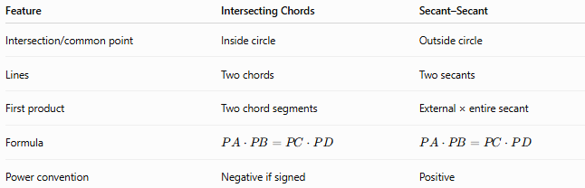
Feature | Intersecting Chords | Secant–Secant
Intersection/common point | Inside circle | Outside circle
Lines | Two chords | Two secants
First product | Two chord segments | External × entire secant
Formula | $$PA⋅PB=PC⋅PD$$ | $$PA⋅PB=PC⋅PD$$
Power convention | Negative if signed | Positive

Comparison with Tangent–Secant
# Source: AI Source: Provided by: [Data Path: Persons Table -> ID Column: 1, Name_En Column: Motasem Essam] -> From: [ChatGPT] on [7/25/2026]
The three relationships form an important group:
Intersecting Chords
$$\boxed{PA⋅PB=PC⋅PD}$$
Secant–Secant
$$\boxed{PA⋅PB=PC⋅PD}$$
Tangent–Secant
$$\boxed{PT^{2}=PA⋅PB}$$
All are manifestations of the Power of a Point principle.
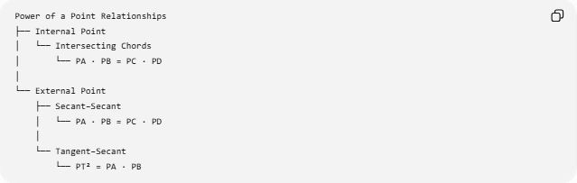
Power of a Point Relationships
├── Internal Point
│ └── Intersecting Chords
│ └── PA · PB = PC · PD
│
└── External Point
├── Secant–Secant
│ └── PA · PB = PC · PD
│
└── Tangent–Secant
└── PT² = PA · PB

Special Case: Equal Chord Segments
# Source: AI Source: Provided by: [Data Path: Persons Table -> ID Column: 1, Name_En Column: Motasem Essam] -> From: [ChatGPT] on [7/25/2026]
If:
$$PA=PC$$
then from:
$$PA⋅PB=PC⋅PD$$
we obtain:
$$PB=PD$$
Therefore, equal corresponding segments produce equal remaining segments.

Special Case: Chords Intersect at the Center
# Source: AI Source: Provided by: [Data Path: Persons Table -> ID Column: 1, Name_En Column: Motasem Essam] -> From: [ChatGPT] on [7/25/2026]
If two chords intersect at the center $O$, each chord is a diameter.
For a circle with radius $r$:
$$OA=OB=OC=OD=r$$
Therefore:
$$OA⋅OB=r^{2}$$
and:
$$OC⋅OD=r^{2}$$
so:
$$\boxed{r^{2}=r^{2}}$$
The theorem is naturally satisfied.

Special Case: Perpendicular Chords
# Source: AI Source: Provided by: [Data Path: Persons Table -> ID Column: 1, Name_En Column: Motasem Essam] -> From: [ChatGPT] on [7/25/2026]
If two chords intersect at a right angle:
$$∠APC={90}^{∘}$$
the Intersecting Chords Theorem still applies:
$$\boxed{PA⋅PB=PC⋅PD}$$
The angle between the chords does not affect the basic product relationship.

Finding a Segment from the Other Three
# Source: AI Source: Provided by: [Data Path: Persons Table -> ID Column: 1, Name_En Column: Motasem Essam] -> From: [ChatGPT] on [7/25/2026]
The theorem can be rearranged in several ways.
Find $PA$
$$\boxed{PA=\frac{PC⋅PD}{PB}}$$
Find $PB$
$$\boxed{PB=\frac{PC⋅PD}{PA}}$$
Find $PC$
$$\boxed{PC=\frac{PA⋅PB}{PD}}$$
Find $PD$
$$\boxed{PD=\frac{PA⋅PB}{PC}}$$

Important Conditions
# Source: AI Source: Provided by: [Data Path: Persons Table -> ID Column: 1, Name_En Column: Motasem Essam] -> From: [ChatGPT] on [7/25/2026]
For the standard theorem:
- There is a circle.
- Two chords intersect.
- The intersection point lies inside the circle.
- Each chord is divided into two segments.
- The products of the two segments are equal.
Thus:
$$A-P-B$$
and:
$$C-P-D$$
with $P$inside the circle.

Classification
# Source: AI Source: Provided by: [Data Path: Persons Table -> ID Column: 1, Name_En Column: Motasem Essam] -> From: [ChatGPT] on [7/25/2026]
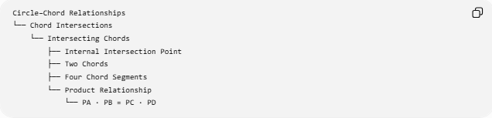
Circle–Chord Relationships
└── Chord Intersections
└── Intersecting Chords
├── Internal Intersection Point
├── Two Chords
├── Four Chord Segments
└── Product Relationship
└── PA · PB = PC · PD
A broader theorem hierarchy is:
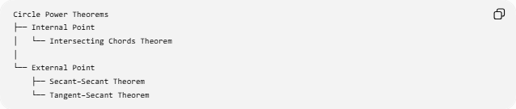
Circle Power Theorems
├── Internal Point
│ └── Intersecting Chords Theorem
│
└── External Point
├── Secant–Secant Theorem
└── Tangent–Secant Theorem

Key Formulas
# Source: AI Source: Provided by: [Data Path: Persons Table -> ID Column: 1, Name_En Column: Motasem Essam] -> From: [ChatGPT] on [7/25/2026]
Main theorem
$$\boxed{PA⋅PB=PC⋅PD}$$
Solve for $PA$
$$\boxed{PA=\frac{PC⋅PD}{PB}}$$
Solve for $PB$
$$\boxed{PB=\frac{PC⋅PD}{PA}}$$
Solve for $PC$
$$\boxed{PC=\frac{PA⋅PB}{PD}}$$
Solve for $PD$
$$\boxed{PD=\frac{PA⋅PB}{PC}}$$

Key Points
# Source: AI Source: Provided by: [Data Path: Persons Table -> ID Column: 1, Name_En Column: Motasem Essam] -> From: [ChatGPT] on [7/25/2026]
- Two chords intersect at a point inside the circle.
- Each chord is divided into two segments.
- The product of the two segments of one chord equals the product of the two segments of the other:
$$\boxed{PA⋅PB=PC⋅PD}$$
- The theorem can be proved using similar triangles.
- It is an important form of the Power of a Point relationship.
- The formula resembles the Secant–Secant Theorem, but the geometric configuration is different.
- For an internal point, signed power is negative, although elementary treatments normally use the positive segment-product equation.

Conclusion
# Source: AI Source: Provided by: [Data Path: Persons Table -> ID Column: 1, Name_En Column: Motasem Essam] -> From: [ChatGPT] on [7/25/2026]
The Intersecting Chords Theorem establishes a fundamental relationship between two chords intersecting inside a circle:
$$\boxed{\text{First Chord Segment}×\text{Second Chord Segment}=\text{Third Chord Segment}×\text{Fourth Chord Segment}}$$
or:
$$\boxed{PA⋅PB=PC⋅PD}$$
It is the internal-point counterpart to the external-point Secant–Secant Theorem and belongs to the broader family of Power of a Point theorems.

